Conclusion
In this analysis “Normal Equation” is the model with both conjugation and R_a, (R_a being the response function to slow down run speed in antibiotic). Significant differences are found when comparing the Mann-Whitney U effect size. The effect sizes of the Normal Model compared to the groups without R_a, both with and without Conjugation (E.S. = -3.832, -3.445), (p < 0.001) are more significant than the effect sizes of just conjugation alone, (Normal vs No Conj Effect Size = -1.543), (p = 0.123) The significant p-values and medians for comparisons involving the change in R_a highlight the dominant impact of the R_a variable, while the p-values between "Normal Equation" vs "No Conj" (p=0.123) and "No R_a with Conj" vs "No R_a No Conj" (p=0.562) support that the conjugation equation provides a non statistically significant time difference for fixation.
The analysis supports the hypothesis that R_a is the dominant factor and has substantial impact on the time to fixation, and conjugation is relatively negligible in its impact on the outcome variable. Even with the skew, the 75th percentile for the Normal Distribution is still lower than 'No R_a No Conj' and 'No R_a No Conj' (6807.5 s vs 9070.0 s and 8160.0 s). The median of the “Normal Equation” is lower than all other distributions, (5001.5 s vs 5390.0 s, 6559.0 s, 6383.0 s).
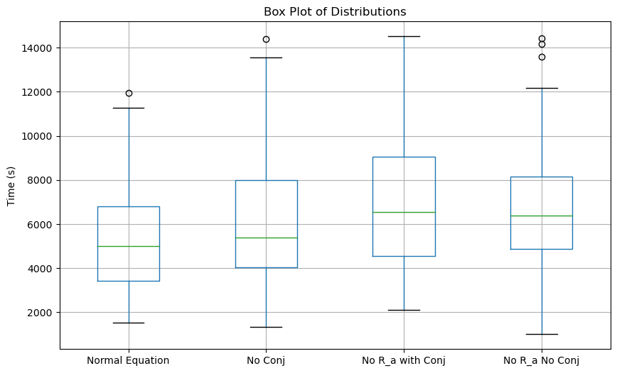
Figure 1
However, if the conjugation equation is combined with R_a, it may help give the bacteria a statistically significant advantage for fixing into a population, as can be seen with "Normal Equation" fixation time having the greatest statistical difference and the lowest median. This was studied further using a permutation test to provide a non-parametric method to assess the significance of the interaction effect between R_a and conjugation. An interaction of (Mean difference when Conjugation is present) - (Mean difference when Conjugation is absent) was calculated. This was used in a permutation test under the assumption of the null hypothesis that there is no statistical difference between the means of conjugation being present. The observed interaction effect of -1053.13s suggests that the combined presence of Conjugation and R_a​ reduces the time to fixation. The p-value of 0.071 indicates that the observed interaction effect was not statistically significant at the 5% level, however the permutation test still shows a notable practical impact that's not highly likely to occur by chance.

The relationship was investigated further using regression analysis. The first model analyzed R_a and Conjugation against log(Time). It confirmed that R_a alone has a statistically significant impact on reducing time $β=-0.1405 (p=0.008)$, supporting the hypothesis that R_a is a dominant factor, while conjugation had no statistically significant impact, $β=-0.0435 (p=0.412)$. A second model was created to investigate the combined effect of conjugation and R_a, (“R_a_Conj”). The interaction had a greater impact on significantly reducing time, $β=-0.1623 (p=0.008)$, and presents evidence that the synergistic relationship provides statistically significant advantage for reducing time to fix into a population. The model was a better fit than the first, but R-squared was relatively low only accounted for 1.8% of the variability. The permutation test provides a practical decrease in time to fixation of around -1053s. This synergistic relationship could be explored further for optimizing bacterial fixation strategies with a more advanced conjugation and plasmid model.
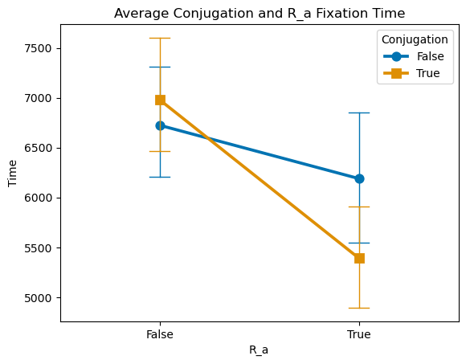
Figure 2

The next variable measured to analyze time to fixation was chemotaxis, whereby the model with “Chemotaxis” was compared to a model with just random diffusion, (“Diffusion”). A Mann-Whitney U test on the skewed time distributions showed a statistically significant difference between the two distributions, with the median of Chemotaxis and Diffusion being 21377.0s and 25591.5s, (p < 0.0001). Regression analysis of chemotaxis on log(time) shows a significant coefficient to reduce time to fixation, $β=-0.1554 (p<0.0001)$, which may be lower but than R_a_Conj but a modest R-squared of 8.5% and significant F-statistic shows the model is a better fit. The magnitude of this effect is lessened by the model being one dimensional, as random diffusion away from higher population concentrations is still directed up the antibiotic gradient. If this model was increased to 2 dimensions, chemotaxis would play a significantly greater effect on directed migration towards food.

A mutation occurring near or within the antibiotic alongside how quickly that mutant migrates towards the area to fix in a low wildtype population is the greatest variable for time to fixation. This stochastic factor is the cause of the high variability. (This is investigated in experiment 3).

